CREATING A WHATEVER
To create your WHATEVER, choose name, look, stats, moves, gear and Hx.

NAME
Name · Name · Name · Name · Name · Name · Name · Name · Name · Name

LOOK
Gender · Look · Look · Look
Clothes · Look · Look · Look
Face · Look · Look · Look
Eyes · Look · Look · Look
Body · Look · Look · Look
STATS
Choose one set:
● Cool Hard Hot Sharp Weird
● Cool Hard Hot Sharp Weird
● Cool Hard Hot Sharp Weird
● Cool Hard Hot Sharp Weird
MOVES
You get all the basic moves. Choose 2 WHATEVER moves.

GEAR
You get:
● item goes here
● item goes here
● item goes here
● item goes here
HX
Everyone introduces their characters by name, look, and outlook. Take your turn.
List the other characters's names.

Go around again for Hx. On your turn, rule goes here
On the other players's turns:
● rule goes here
● rule goes here
Introducing

THE WHATEVER
Lorem ipsum dolor sit amet, consectetuer adipiscing elit, sed diam nonummy nibh euismod tincidunt ut laoreet dolore magna aliquam erat volutpat. Ut wisi enim ad minim veniam, quis nostrud exercitation ulliam corper suscipit lobortis nisl ut aliquip ex ea commodo consequat.

experience

◯ ◯ ◯ ◯ ◯↦ IMPROVEMENT
Whenever you roll a highlighted stat, and whenever you reset your Hx with a character, mark an experience circle. When you mark the 5th one, improve, then erase all experience marks. Each time you improve, choose one of the options. Check it off; you can't choose it again.
☐ rule goes here ☐ rule goes here
☐ rule goes here ☐ rule goes here
☐ rule goes here ☐ rule goes here
☐ rule goes here ☐ rule goes here
☐ rule goes here ☐ rule goes here

Starting with your 6th improvement, the following options are also available:
☐ +1 to any stat (max +3) ☐ retire your character (to safety)
☐ choose 3 basic moves, advance them ☐ create an additional character to play
☐ advance the other 4 basic moves ☐ change your character to a new type

BARTER
1‑barter will cover a month's living expenses, if your tastes aren't too grand.
As a one-time expenditure, and very subject to availability, 1‑barter might count for: a night in high luxury and company; one square meal each for around 30 people; a typical family's entire food store; the material costs of a crash resuscitation by an angel; a week's hire of the protective companionship of a battlebabe or gunlugger; any weapon, gear, or fashion not valuable or hi‑tech; repair of a piece of hi‑tech gear by a savvyhead; a year's tribute to a warlord; a month's maintenance and repairs for a hi‑performance vehicle well-used; bribes, fees, and gifts sufficient to get you into almost anyone's presence.
If you're charging someone wealthy for your services, 1‑barter is the going rate for: description goes here, description goes here, description goes here

a character playbook for

APOCALYPSE WORLD

WHATEVER SPECIAL STUFF
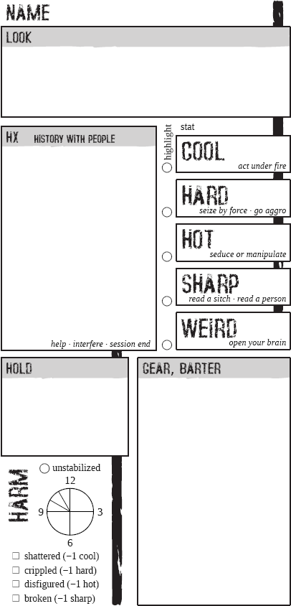
This is where we list your special stuff. Every PC Class has its own unique stuff. Some of them involve selections:
☐ option goes here ☐ option goes here
☐ option goes here ☐ option goes here
☐ option goes here ☐ option goes here

Other class-based details may be written here: gangs, holds, vehicles, etc.
WHATEVER MOVES
☐ here is one of your class moves.
☐ here is one of your class moves.
☐ here is one of your class moves.
☐ here is one of your class moves.
☐ here is one of your class moves.
☐ here is one of your class moves.

When you and another character have sex, description goes here.

MORE MOVES

